PROCEDURE FOR VIEW OR DOWNLOAD TAX CREDIT STATEMENT (FORM 26AS)

STEP 1: - Go the site: https://incometaxindiaefiling.gov.in/ you’ll be greeted by the following screen.

If you have Register yourself and you have an account then, please click “Login Here”

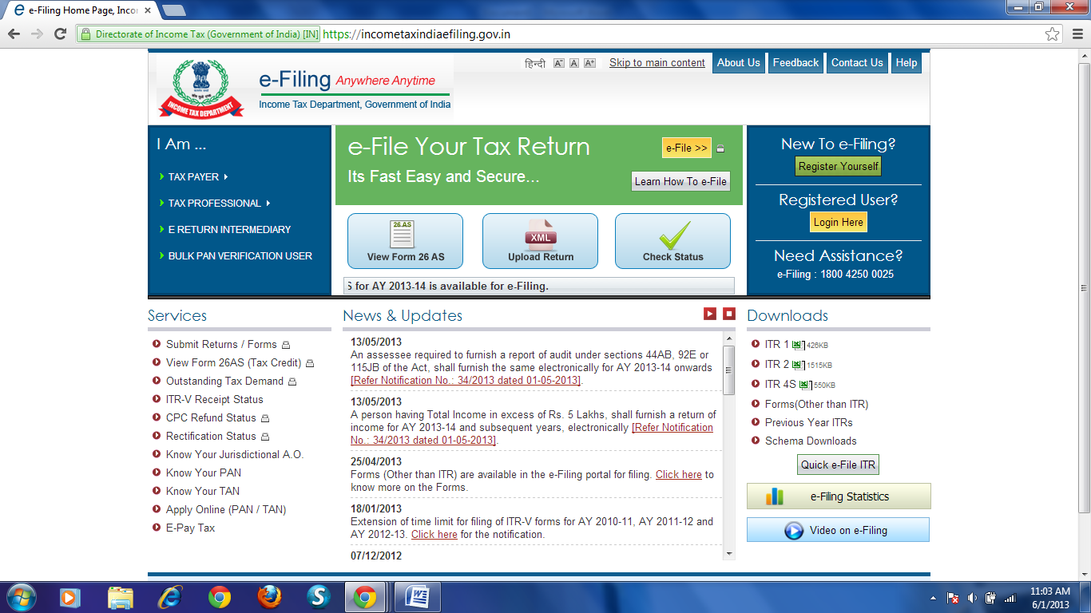
CLICK ON LOGIN HERE

STEP 2:- In Step 2 you will require your PAN NO. , PASSWORD (which you entered at the time of registered yourself) and your DATE OF BIRTH/DATE OF INCORPORATION.
After clicking in “Login Here” Following screen will appear

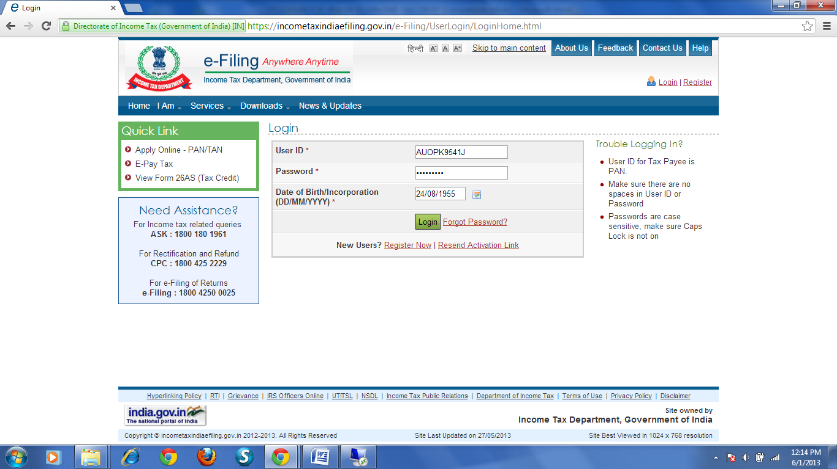
3RD TYPE YOUR DATE OF BIRTH/DATE OF INCORPORATION (DD/MM/YYYY)
2ND TYPE PASSWORD
1ST TYPE YOUR PAN NO HERE
4TH CLICK IN LOGIN

- 1ST Type your PAN NO.(e.g. ABCDE1234F) in space provided for User ID (i.e. your PAN NO will be your User ID)
- 2nd Type your Password in space provided for password
- 3rd Type your Date of Birth (for individual) or Date of Incorporation (for others) in format of DD/MM/YYYY
- 4th Click in Login

STEP 3:- After successful login following screen will appear, you have to click on view form 26 AS (Tax Credit)

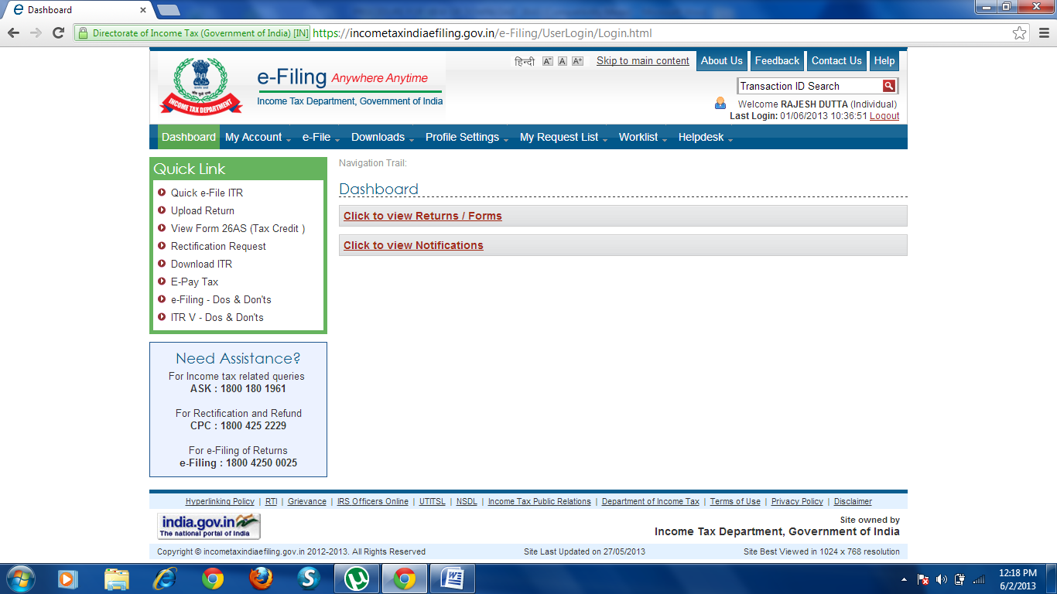
CLICK ON VIEW FORM 26AS (TAX CREDIT)

STEP 4:- In step 4 Confirm page will appear in the screen you have to confirm it by clicking on CONFIR

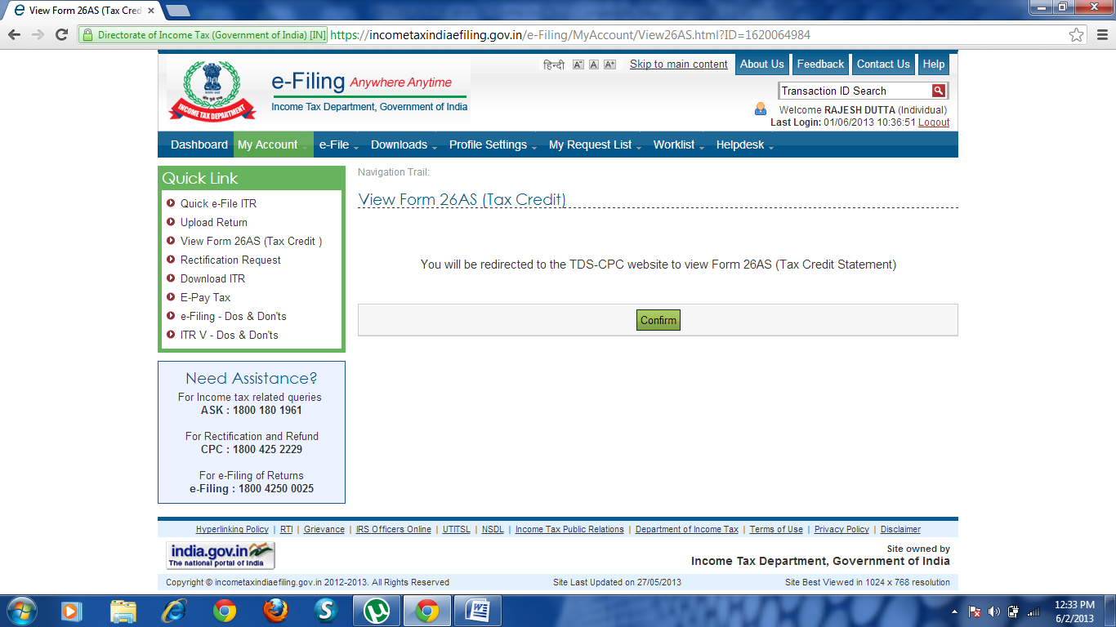
CLICK ON CONFIRM

STEP 5:- After confirm above page new tab will appear for TRACES/View Form 26AS in the new tab screen, you have to click on View Tax Credit (Form 26AS)

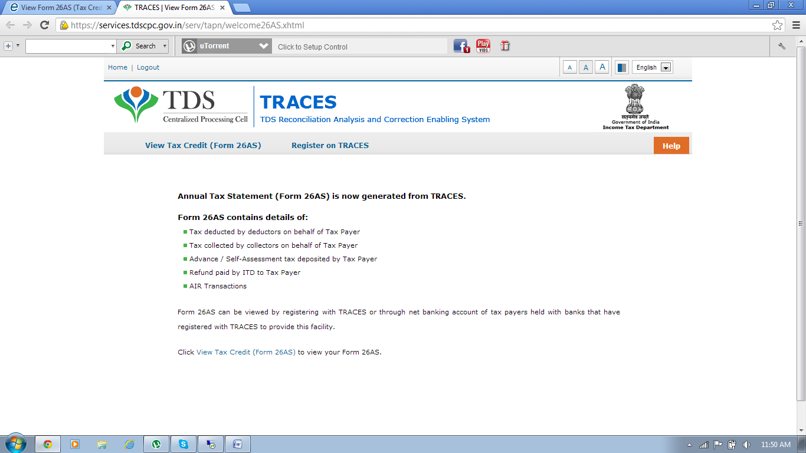
CLICK ON VIEW TAX CREDIT (FORM 26AS)
Ste

STEP 6:- After clicking on View Tax Credit (Form 26AS) following screen will screen will appear

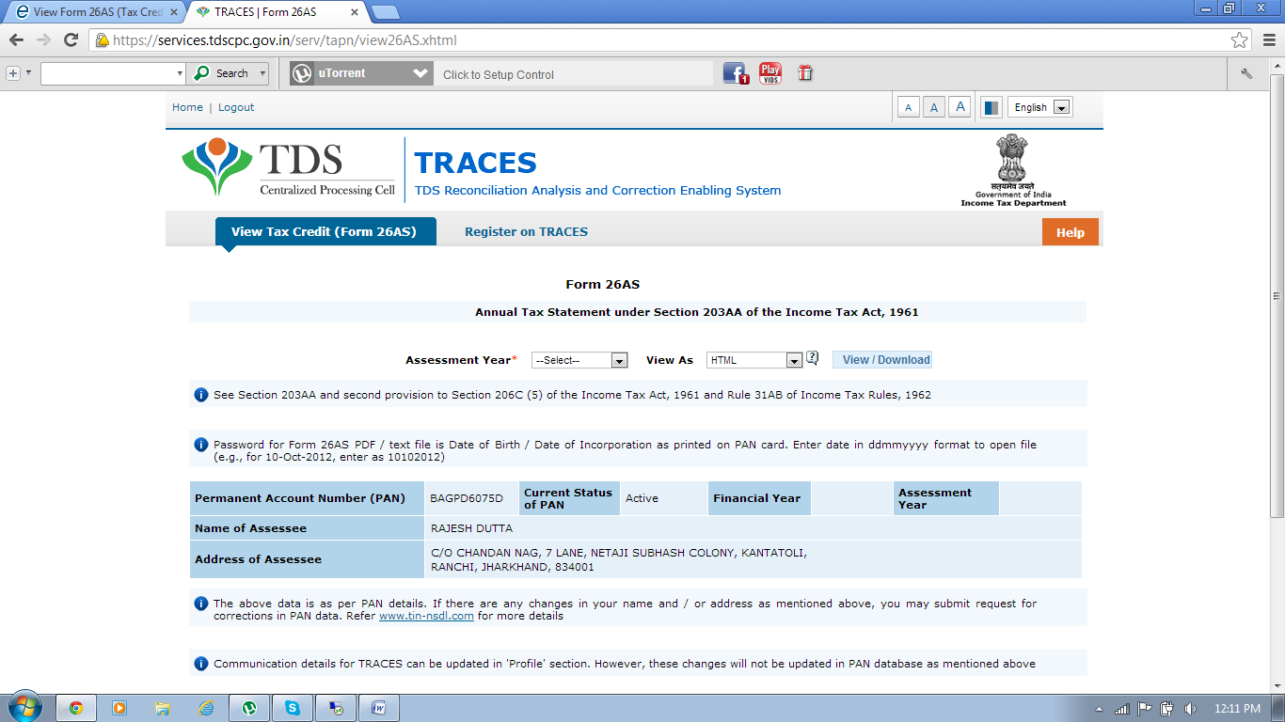
1ST SELECT THE ASSESSMENT YEAR
2ND SELECT THE FILE TYPE
3RD CLICK ON VIEW/DOWNLOAD

- 1ST You have to Select the Assessment Year for which you have to View/Download Tax Credit Statement i.e.26AS

- 2ND You have to Select the File Type (i.e. HTML, text or PDF)

- 3RD click on View/Download

NOTE: - (1) if you have to View 26AS in HTML File Type after clicking on View/Download screen will display you Tax Credit Statement i.e.26AS

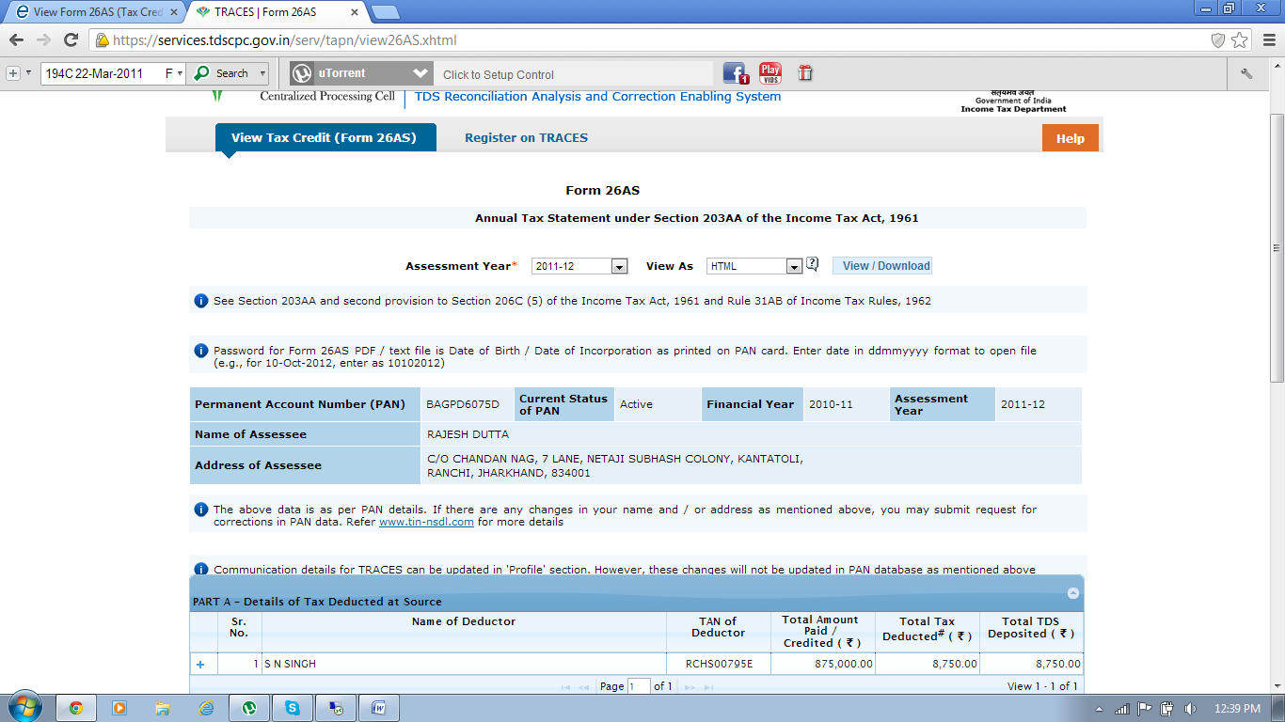
TO VIEW DETAILED OF TAX CREDIT IN HTML FILE TYPE CLICK ON + SYMBOL

(2) To view Tax credit Statement in Text & PDF File Type you have to first download it by clicking on View/Download as shown in Step 6, Note that to open this downloaded file you need a password, the password will be Date Of Birth/Date Of Incorporation which you entered at the time of login. The Format of password will be DDMMYYY

